
Media Contact:
Jim Badger
State Bank
317-858-6196
jbadger@statebank1910.bank

FOR IMMEDIATE RELEASE 10-07-2026

State Bank Welcomes Denise Malm as Speedway Branch Manager

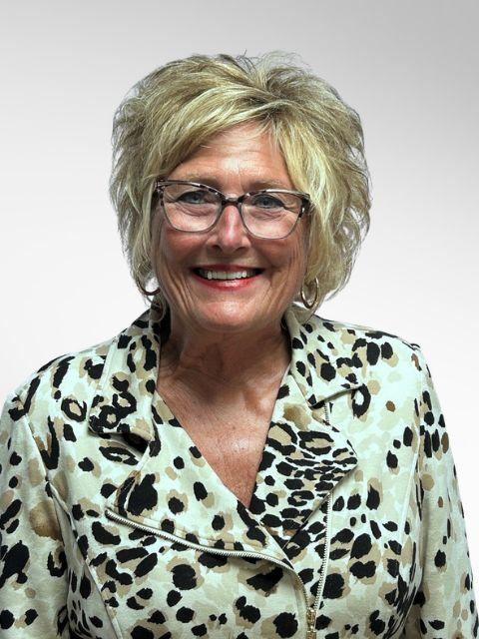
Speedway, Ind. – State Bank is pleased to announce the addition of Denise Malm as Vice President/Branch Manager for the Bank's new Speedway location, which is currently under construction and scheduled for completion in Spring 2027.
Until the new branch opens, Malm will be actively connecting with Speedway residents, business owners, and community leaders while becoming immersed in State Bank's relationship-focused approach to banking. She will also be working closely with customers and prospects while gaining extensive knowledge of State Bank's premier business banking, treasury management, and cash management technology platforms.
Malm brings more than two decades of banking, sales, business development, and leadership experience to State Bank. Most recently, she served as Banking Center Manager for an out-of-state bank, where she led branch sales and operations, developed new business relationships, and guided teams to achieve exceptional performance. Her banking career also includes leadership positions with several multi-state regional banks, where she consistently earned recognition for sales excellence, customer service, and business development achievements.
In addition to her banking experience, Malm has served as an educator, business professional, and community leader throughout Central Indiana. Her diverse professional background, combined with a strong commitment to relationship building, has enabled her to develop trusted partnerships with businesses, families, and community organizations.
"Denise is a tremendous addition to our team and an ideal leader for our future Speedway location," said Nick Bontreger, Senior Vice President, Retail Administration. "Her extensive banking experience, proven leadership abilities, and deep connections within the Speedway community align perfectly with State Bank's commitment to delivering exceptional service and building lasting relationships. As we prepare to open our new Speedway branch, Denise will play a critical role in introducing State Bank to the community and helping local businesses and families discover the difference a true community bank can make."
Malm's strong ties to Speedway make her uniquely positioned to serve the community. She currently serves on the Board of Directors for the Greater Speedway Chamber of Commerce and is actively involved with the Speedway Lions Club and Home Artisans of Indiana's Speedway chapter.
"I am excited to join State Bank and help establish our presence in Speedway," said Malm. "State Bank's reputation for personalized service, local decision-making, and community involvement is what attracted me to the organization. I look forward to building relationships throughout Speedway and helping individuals, families, and business owners achieve their financial goals."

(MORE)
The new Speedway branch represents State Bank's continued commitment to growth and investment in the communities it serves. Upon completion in Spring 2027, the branch will provide personal banking, business banking, commercial lending, treasury management, and wealth management services designed to help local customers thrive.
State Bank has proudly served Indiana communities since 1910, delivering personalized financial solutions to individuals, families, and businesses. Through local expertise and commitment to exceptional customer service, State Bank continues to help communities grow and thrive.
About State Bank – State Bank is a $980 million community bank dedicated to serving the financial needs of individuals, families, and businesses across central Indiana. The bank operates 11 full‑service locations and participates in the AllPoint™ network, providing customers with convenient access to more than 55,000 surcharge‑free ATMs nationwide. Since 2017, State Bank has consistently earned a 5‑Star rating from Bauer Financial, recognizing its strong performance and financial stability. State Bank maintains branch offices in Avon, Brownsburg, Plainfield, Lizton, and Pittsboro in Hendricks County; two locations in Lebanon and one in Zionsville in Boone County; Carmel in Hamilton County; Lafayette in Tippecanoe County; Lapel in Madison County; with a new location opening next year in Speedway, Marion County. To learn more, visit www.StateBank1910.bank.

#####

